BroadcastReceiver可以接收到系统的广播信息

**两种广播类型**

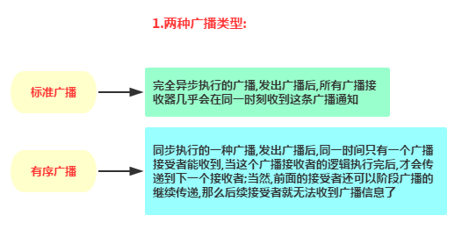

**接收系统广播**

**新建广播接收器MyBRReceiver.java**

public class MyBRReceiver extends BroadcastReceiver {  
 @Override  
 public void onReceive(Context context, Intent intent) {  
 Toast.*makeText*(context,"网络状态发生改变~",Toast.*LENGTH_SHORT*).show();  
 }  
}

**注册广播接收器**

我们有2中注册方式

动态注册：

public class MainActivity extends AppCompatActivity {  
  
 MyBRReceiver myReceiver;  
  
 @Override  
 protected void onCreate(Bundle savedInstanceState) {  
 super.onCreate(savedInstanceState);  
 setContentView(R.layout.*activity_main*);  
 //核心部分代码：  
 myReceiver = new MyBRReceiver();  
 IntentFilter itFilter = new IntentFilter();  
 itFilter.addAction("android.net.conn.CONNECTIVITY_CHANGE");  
 // 注册接收器  
 registerReceiver(myReceiver, itFilter);  
 }  
  
 //别忘了将广播取消掉哦~  
 @Override  
 protected void onDestroy() {  
 super.onDestroy();  
 unregisterReceiver(myReceiver);  
 }  
}

静态注册（个人测试不成功）：

<application  
 android:allowBackup="true"  
 android:icon="@mipmap/ic_launcher"  
 android:label="@string/app_name"  
 android:roundIcon="@mipmap/ic_launcher_round"  
 android:supportsRtl="true"  
 android:theme="@style/AppTheme">  
  
 <receiver android:name=".MyBRReceiver">  
 <intent-filter>  
 <action android:name = "android.net.conn.CONNECTIVITY_CHANGE"/>  
 </intent-filter>  
 </receiver>  
</application>

**发送广播**

**发送**

@Override  
protected void onCreate(Bundle savedInstanceState) {  
 super.onCreate(savedInstanceState);  
 setContentView(R.layout.*activity_main*);  
  
 Button btn = findViewById(R.id.*start*);  
 btn.setOnClickListener(new View.OnClickListener() {  
 @Override  
 public void onClick(View v) {  
 // 发送广播，动作为 com.example.broadcasttest.MY_BROADCAST  
 sendBroadcast(new Intent("com.example.broadcasttest.MY_BROADCAST"));  
 }  
 });  
}

**接收**

在我们的接收器中可以这样判断

public class MyBRReceiver extends BroadcastReceiver {  
 private final String ACTION_BOOT = "com.example.broadcasttest.MY_BROADCAST";  
 @Override  
 public void onReceive(Context context, Intent intent) {  
 if(ACTION_BOOT.equals(intent.getAction()))  
 Toast.*makeText*(context, "收到告白啦~",Toast.*LENGTH_SHORT*).show();  
 }  
}